Log-In screen.

|  |  |  |  |  |  |  |
| --- | --- | --- | --- | --- | --- | --- |
| Test Noo | Input. | Expected output. | Actual Output. | Correct result? | Justification. | Test type. |

|  |  |  |  |  |  |  |
| --- | --- | --- | --- | --- | --- | --- |
| 1 | Inputting the correct username and password. | The main menu shows up. | Main Menu loads. | Yes | Allows the player to access the main menu. | Valid |

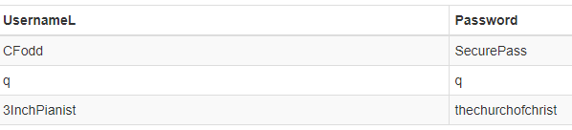(What’s in my database.)

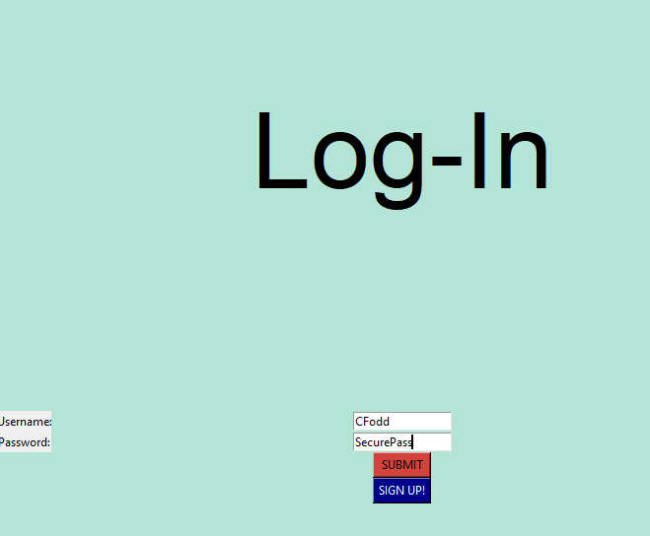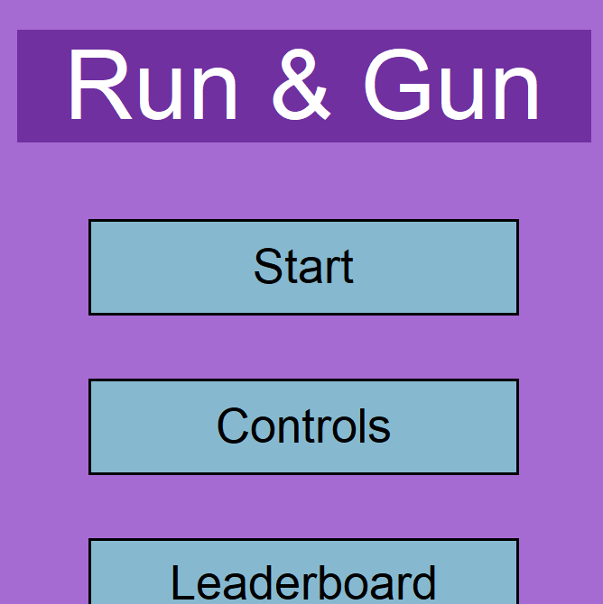

|  |  |  |  |  |  |  |
| --- | --- | --- | --- | --- | --- | --- |
| 2 | Inputting the correct username but wrong password. | Message shows up saying there was an incorrect input | Stays on the main menu and gives output. | Yes | Let's the user know they inputted something incorrect without specifying so hackers will have a harder time accessing an account. | Invalid |

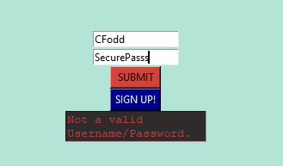

|  |  |  |  |  |  |  |
| --- | --- | --- | --- | --- | --- | --- |
| 2 | Inputting the correct password but wrong username. | Message shows up saying there was an incorrect input | Stays on the main menu and gives output. | Yes | Let's the user know they inputted something incorrect without specifying so hackers will have a harder time accessing an account. | Invalid |

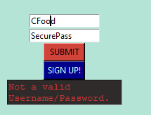

|  |  |  |  |  |  |  |
| --- | --- | --- | --- | --- | --- | --- |
| 3 | Pressing the sign-up button. | Opens the sign-up menu. | Opens the sign-up menu. | Yes | Lets a new user create an account. | Valid |

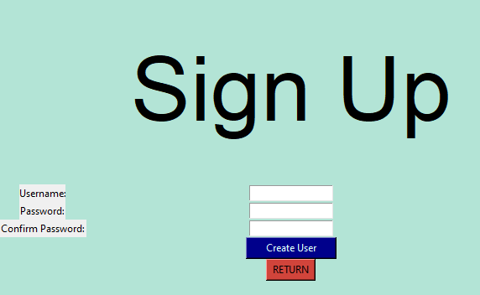

|  |  |  |  |  |  |  |
| --- | --- | --- | --- | --- | --- | --- |
| 3 | Inputting a unique username and the same password twice. | Creates new username and password into the log-in table and adds the player to scoreboard too, with a default rank and Score. | Does as described. | Yes | Lets a new user create an account. | Valid |

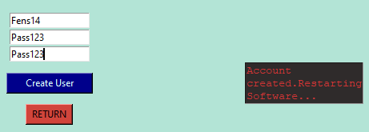

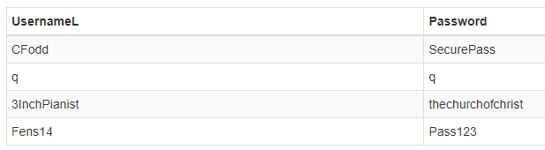

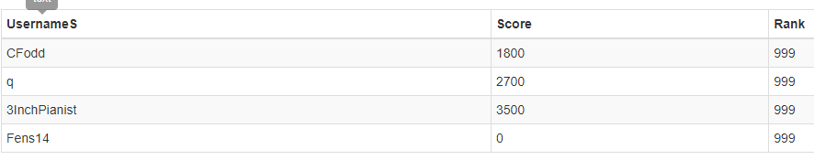

|  |  |  |  |  |  |  |
| --- | --- | --- | --- | --- | --- | --- |
| 3 | Inputting a non-unique username. | The user isn’t allowed to create the name and is given a message. | Does as described. | Yes | Having the same username twice will cause collisions in the Scoreboard since it uses the usernames as a foreign key. | Invalid |

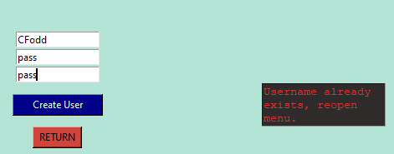

|  |  |  |  |  |  |  |
| --- | --- | --- | --- | --- | --- | --- |
| 3 | Inputting a unique username but the 2 passwords don’t match. | Gives a message telling the user their error. | Does as described. | Yes | Ensures the user isn’t creating a password with a spelling error. | Invalid |

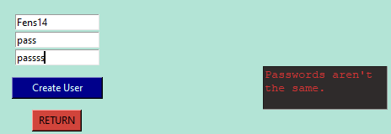

|  |  |  |  |  |  |  |
| --- | --- | --- | --- | --- | --- | --- |
| 3 | Either password or username is above 20 characters. | Gives a message telling the user their error. | Does as described. | Yes | Stops usernames from being too long. | Boundry |

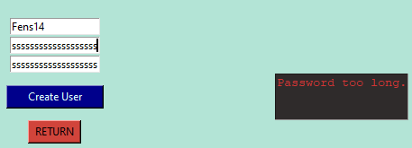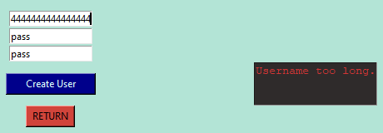

|  |  |  |  |  |  |  |
| --- | --- | --- | --- | --- | --- | --- |
| 3 | Pressing the return button. | Closes the sign-up menu. | Closes the sign-up menu. | Yes | Lets the user return to the log-in menu. | Valid |

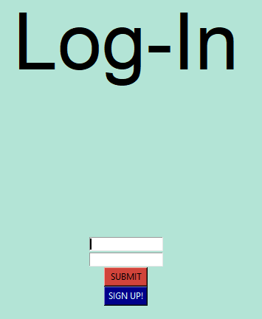

Main Menu screen.

|  |  |  |  |  |  |  |
| --- | --- | --- | --- | --- | --- | --- |
| Test Noo | Input. | Expected output. | Actual Output. | Correct result? | Justification. | Test type. |

|  |  |  |  |  |  |  |
| --- | --- | --- | --- | --- | --- | --- |
| 1 | Clicking on the controls button. | The controls menu shows up. | Controls Menu loads. | Yes | Allows the player to see the controls they’ll be using. | Valid |

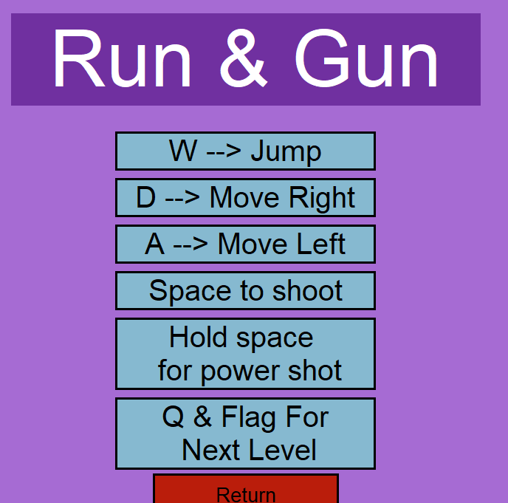

|  |  |  |  |  |  |  |
| --- | --- | --- | --- | --- | --- | --- |
| 1 | Clicking on the return button. | The controls menu closes. | Controls Menu closes. | Yes | Allows the player to return to the main menu. | Valid |

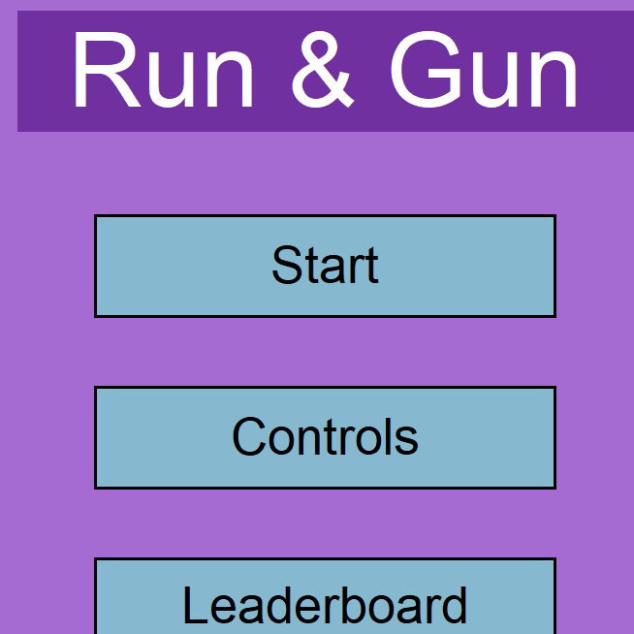

|  |  |  |  |  |  |  |
| --- | --- | --- | --- | --- | --- | --- |
| 1 | Clicking on the leaderboard button. | The leaderboard menu shows up. | Leaderboard Menu loads. | Yes | Allows the player to see where they stand in the rankings. | Valid |

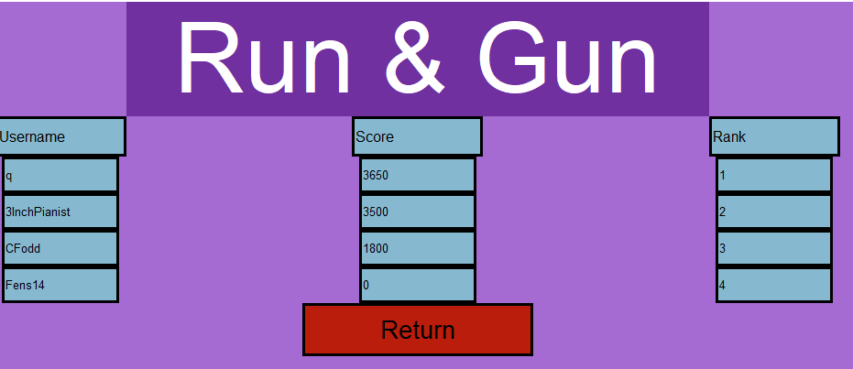

|  |  |  |  |  |  |  |
| --- | --- | --- | --- | --- | --- | --- |
| 1 | Clicking on the return button. | The leaderboard menu closes. | Leaderboard Menu closes. | Yes | Allows the player to return to the main menu. | Valid |



|  |  |  |  |  |  |  |
| --- | --- | --- | --- | --- | --- | --- |
| 1 | Clicking on the play button. | The game shows up. | Does as described. | Yes | Lets the game start. | Valid |

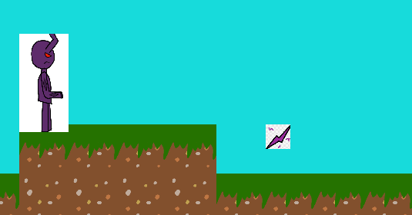

Player controls.

|  |  |  |  |  |  |  |  |  |  |  |  |  |
| --- | --- | --- | --- | --- | --- | --- | --- | --- | --- | --- | --- | --- |
| Test Noo | | Input. | | Expected output. | | Actual Output. | Correct result? | | | Justification. | Test type. | |
| 1 | Pressing W. | | The player jumps. | | Works as intended. | | | Yes | Lets the player platform. | | | Valid |

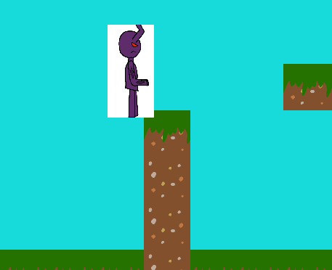

|  |  |  |  |  |  |  |
| --- | --- | --- | --- | --- | --- | --- |
| 1 | Pressing D. | The player moves right. | Works as intended. | Yes | Lets the player move in the level. | Valid |

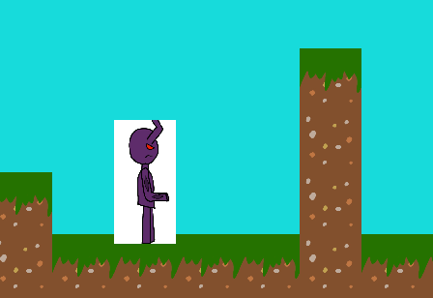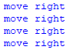

|  |  |  |  |  |  |  |
| --- | --- | --- | --- | --- | --- | --- |
| 1 | Pressing A. | The player left. | Works as intended. | Yes | Lets the player move in the level. | Valid |

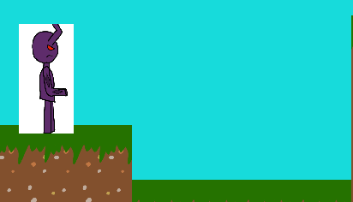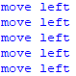

|  |  |  |  |  |  |  |
| --- | --- | --- | --- | --- | --- | --- |
| 1 | Pressing space. | The player shoots up to 3 bullets. | Works as intended. | Yes | Lets the player kill enemies. | Valid |

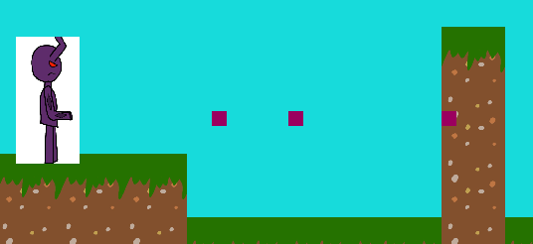

|  |  |  |  |  |  |  |
| --- | --- | --- | --- | --- | --- | --- |
| 1 | Holding space. | The player shoots a charged shot. | Works as intended. | Yes | Lets the player kill the enemies in a skilled way. | Valid |

|  |  |  |  |  |  |  |
| --- | --- | --- | --- | --- | --- | --- |
| 2 | Player captures the flag. | Next level occurs and flag disappears. | Works as intended, requires the player to press Q after getting the flag also gives 200 score. | Yes | Stops the player from resetting the level. | Valid |

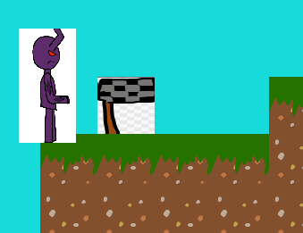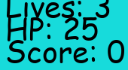

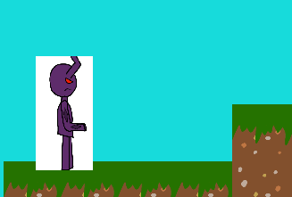

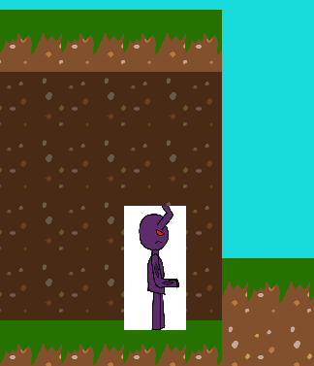(Proceed to next level after pressing Q)

|  |  |  |  |  |  |  |
| --- | --- | --- | --- | --- | --- | --- |
| 1 | Getting sparks. | Score increases by 50 and disappears. | Works as intended. | Yes | Lets the player recover from a fight. | Valid |

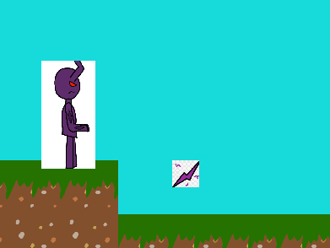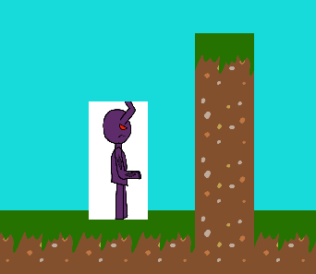

|  |  |  |  |  |  |  |
| --- | --- | --- | --- | --- | --- | --- |
| 1 | Getting the HP power-up. | HP increases by 5, receive 100 score and disappears. | Works as intended. | Yes | Lets the player recover from a fight. | Valid |

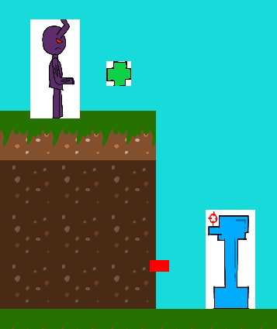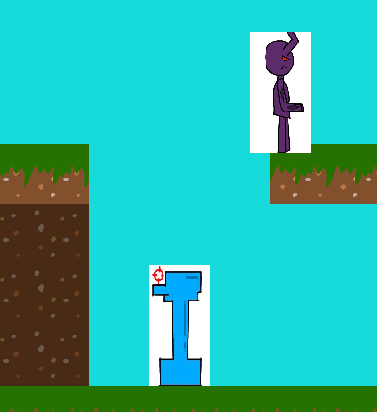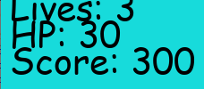

|  |  |  |  |  |  |  |
| --- | --- | --- | --- | --- | --- | --- |
| 1 | Getting the life power up. | Lives increase by one, receive 100 score and disappears. | Works as intended. | Yes | Works as a reward for the player. | Valid |

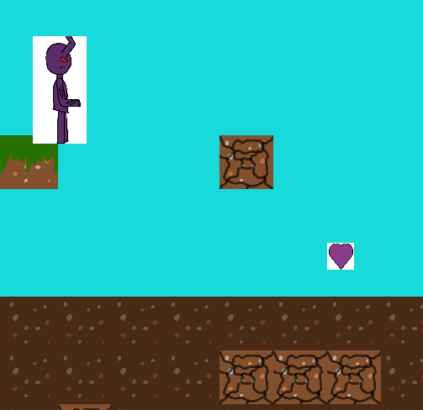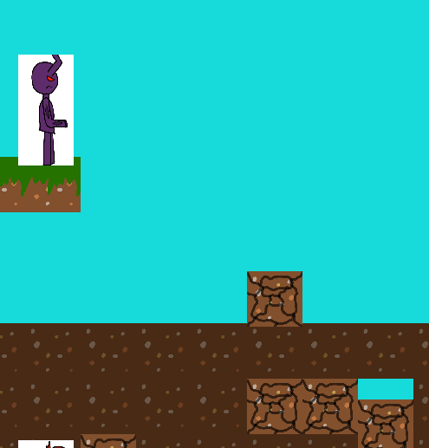

|  |  |  |  |  |  |  |
| --- | --- | --- | --- | --- | --- | --- |
| 1 | Getting invincibility power-up. | Players are immune to damage, receive 100 score and disappears. | Works as intended; player has a yellow box around them. | Yes | Works as a reward for the player. | Valid |

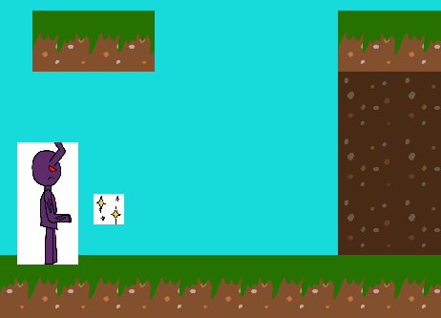

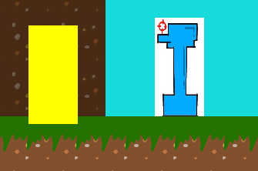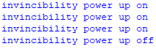

(Player took damage due to the power up wearing off whilst screenshotting)

|  |  |  |  |  |  |  |
| --- | --- | --- | --- | --- | --- | --- |
| 1 | Getting power shot power-up. | Players do power shots; they have bigger hit boxes and do more damage, receive 100 score and disappears. | Works as intended. | Yes | Works as a reward for the player. | Valid |

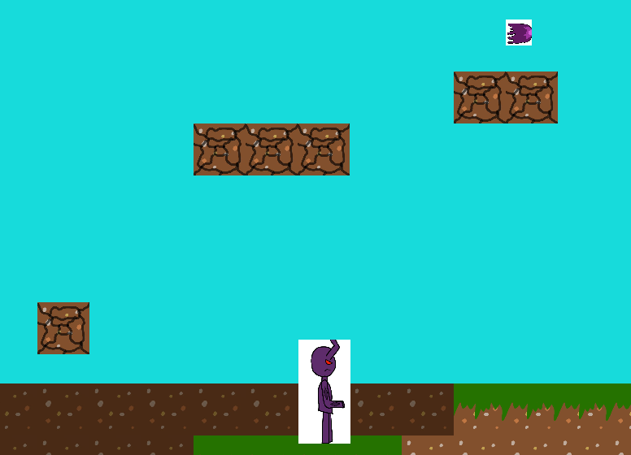

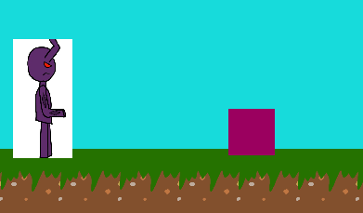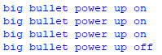

|  |  |  |  |  |  |  |
| --- | --- | --- | --- | --- | --- | --- |
| 1 | Player dies. | Player loses life and restarts the level with the score they started the level with. | Works as intended. | Yes | A consequence for losing. | Valid |

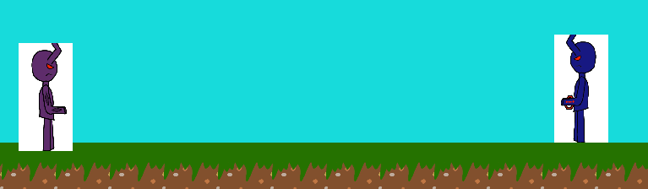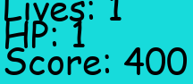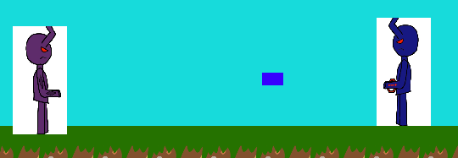

|  |  |  |  |  |  |  |
| --- | --- | --- | --- | --- | --- | --- |
| 1 | Players lose all their HP. | Player loses a life. | Works as intended. | Yes | A consequence for losing. | Valid |



|  |  |  |  |  |  |  |
| --- | --- | --- | --- | --- | --- | --- |
| 1 | Player stands on the bottom of the level. | Player loses a life. | Works as intended. | Yes | A consequence for miss playing. | Valid |

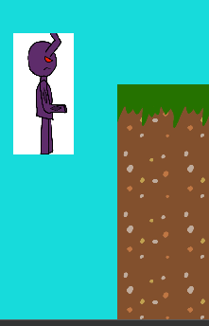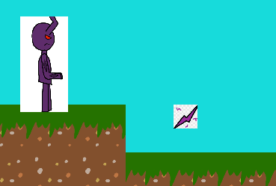

|  |  |  |  |  |  |  |
| --- | --- | --- | --- | --- | --- | --- |
| 1 | Players lose all their lives. | They restart the entire game. | Works as intended, the game closes when they lose all their lives. | Yes | A consequence for losing. | Valid |

|  |  |  |  |  |  |  |
| --- | --- | --- | --- | --- | --- | --- |
| 1 | Players is damaged. | Player loses HP and becomes invincible for a short period of time. | Works as intended, there’s a purple box over the player when this occurs. | Yes | Prevents further damage being taken. | Valid |

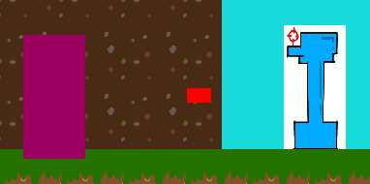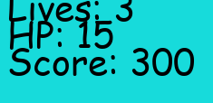(Took multiple shots)

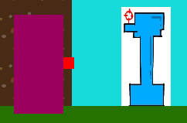(This bullet goes through the player because they’re invincible)

Terrain Testing.

|  |  |  |  |  |  |  |
| --- | --- | --- | --- | --- | --- | --- |
| Test Noo | Input. | Expected output. | Actual Output. | Correct result? | Justification. | Test type. |

|  |  |  |  |  |  |  |
| --- | --- | --- | --- | --- | --- | --- |
| 1 | Players stands on the ground. | They stand on it. | Works as intended, only works on grass and cracked ground. | Yes | Let's the player traverse the level. | Valid |

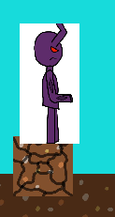

|  |  |  |  |  |  |  |
| --- | --- | --- | --- | --- | --- | --- |
| 1 | Players runs into the wall. | They don’t go through it. | Works as intended, only on dirt. | Yes | Stops the player from just running through the level. | Valid |

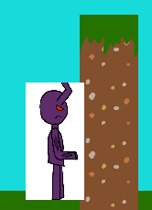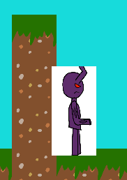

|  |  |  |  |  |  |  |
| --- | --- | --- | --- | --- | --- | --- |
| 1 | Players hit their heads on the bottom of the blocks. | They don’t go through it. | Works as intended, only on dirt and cracked ground. | Yes | Stops player from being able to skip/exploit the platforming sections. | Valid |

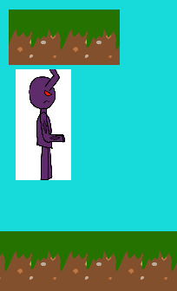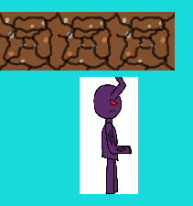

|  |  |  |  |  |  |  |
| --- | --- | --- | --- | --- | --- | --- |
| 1 | Player stands on cracked ground. | The platform should fall. | Works as intended. | Yes | Adds challenge to the platforming. | Valid |

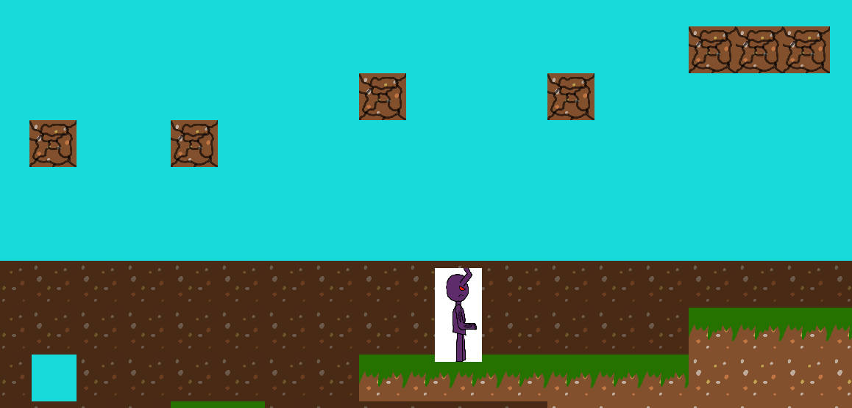

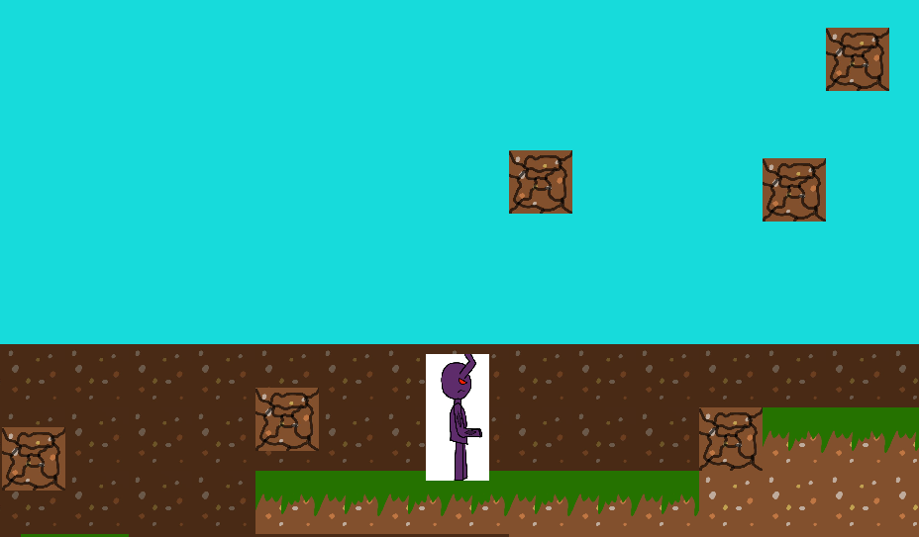

Turret Testing.

|  |  |  |  |  |  |  |
| --- | --- | --- | --- | --- | --- | --- |
| Test Noo | Input. | Expected output. | Actual Output. | Correct result? | Justification. | Test type. |

|  |  |  |  |  |  |  |
| --- | --- | --- | --- | --- | --- | --- |
| 1 | Player stands near the turret. | The turret will fire a bullet. | Works as intended. | Yes | Ensure the player doesn’t just run at the enemy. | Valid |

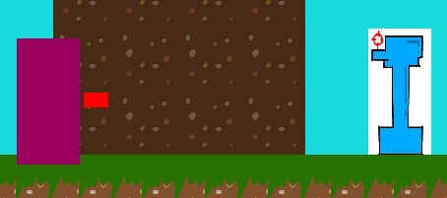

|  |  |  |  |  |  |  |
| --- | --- | --- | --- | --- | --- | --- |
| 1 | Player collides with the enemy/bullet. | The player receives damage. | Works as intended. | Yes | Creates a consequence for charging at the turret/ adds difficulty in killing the enemy. | Valid |



|  |  |  |  |  |  |  |
| --- | --- | --- | --- | --- | --- | --- |
| 1 | Turret collides with regular player bullet. | The enemy receives damage, should be affected by difficulty scaling. | Works as intended, does 1 damage at default/higher difficulties. | Yes | let's the player do damage to the enemy. | Valid |

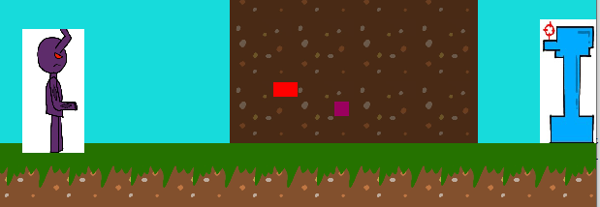

|  |  |  |  |  |  |  |
| --- | --- | --- | --- | --- | --- | --- |
| 1 | Turret collides with charged player bullet. | The enemy receives damage, shouldn’t be affected by difficulty scaling. | Works as intended does 3 damage (1 hit KO). | Yes | Let’s the player do substantial damage do turrets if they’re skilled enough with the timing. | Valid |

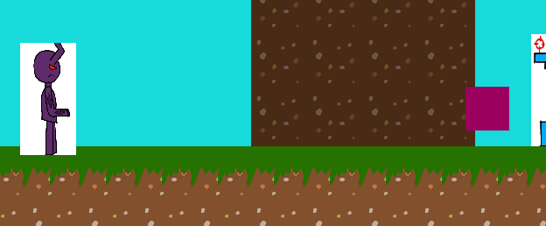

|  |  |  |  |  |  |  |
| --- | --- | --- | --- | --- | --- | --- |
| 1 | Turret collides with regular player bullet but they the power-shot power up. | The enemy receives damage. | Works as intended, does 3 damage (1 hit KO). | Yes | Let’s the player do substantial damage to turrets if they managed to obtain the power up. | Valid |

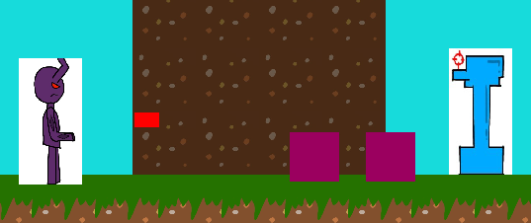

|  |  |  |  |  |  |  |
| --- | --- | --- | --- | --- | --- | --- |
| 1 | Turret HP reaches 0. | The enemy should disappear, and the player receives 100 score. | Works as intended | Yes | let's the player remove their threat. | Valid |



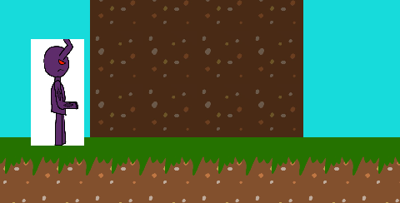

**Testing difficulty scaling**

|  |  |  |  |  |  |  |
| --- | --- | --- | --- | --- | --- | --- |
| 1 | Turret collides with regular player bullet, the player has more than 4 lives or more than 20HP. And player collides with turret bullet with these stats. | The turret should do 3 damage and if the player kills the turret with these stats, then the likelihood of the HP drop occurring should be 1 in 15. Also, the player should only do 1 damage. | Works as intended. | Yes | Adds more difficulty for skilled players. | Boundary |



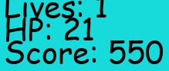



|  |  |  |  |  |  |  |
| --- | --- | --- | --- | --- | --- | --- |
| 1 | If the player has exactly 4 lives. And player collides with turret bullet with these stats. | The turret should do 2 damage and if the player kills the turret with these stats, then the likelihood of the HP drop occurring should be 1 in 15. Also, the player should only do 1 damage. | Works as intended. | Yes | Adds some difficulty for players who are playing well. | Boundary |



|  |  |  |  |  |  |  |
| --- | --- | --- | --- | --- | --- | --- |
| 1 | If the player has less than 2 lives and they shoot the tower. And player collides with turret bullet with these stats. | The turret should do 1 damage and if the player kills the turret with these stats, then the likelihood of the HP drop occurring should be 1 in 5. Also, the player should do 2 damage. | Works as intended. | Yes | Removes difficulty for players who are struggling with the game. | Boundary |



Gun Bot Testing.

|  |  |  |  |  |  |  |
| --- | --- | --- | --- | --- | --- | --- |
| Test Noo | Input. | Expected output. | Actual Output. | Correct result? | Justification. | Test type. |

|  |  |  |  |  |  |  |
| --- | --- | --- | --- | --- | --- | --- |
| 1 | Player stands near the bot. | The bot will fire at the player. | Works as intended. | Yes | Ensure the player doesn’t just run at the enemy. | Valid |

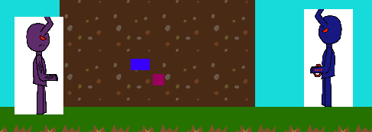

|  |  |  |  |  |  |  |
| --- | --- | --- | --- | --- | --- | --- |
| 1 | Player gets closer to the bot. | The bot will move away from the player. | Works as intended. | Yes | Ensure the player doesn’t just run at the enemy. | Valid |



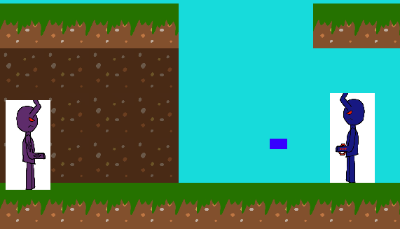

|  |  |  |  |  |  |  |
| --- | --- | --- | --- | --- | --- | --- |
| 1 | Player collides with the bullet. | The player receives damage. | Works as intended. | Yes | Creates a consequence for charging at the bot/ adds difficulty in killing the enemy. | Valid |

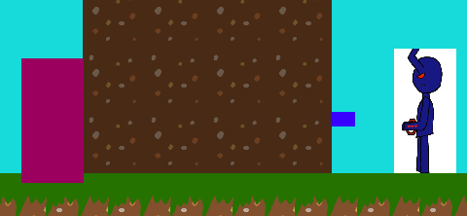

|  |  |  |  |  |  |  |
| --- | --- | --- | --- | --- | --- | --- |
| 1 | Bot collides with regular player bullet. | The enemy receives damage, should be affected by difficulty scaling. | Works as intended, does 1 damage at default/higher difficulties. | Yes | let's the player do damage to the enemy. | Valid |



|  |  |  |  |  |  |  |
| --- | --- | --- | --- | --- | --- | --- |
| 1 | Bot collides with charged player bullet. | The enemy receives damage, shouldn’t be affected by difficulty scaling. | Works as intended does 3 damage. | Yes | Let’s the player do substantial damage do bots if they’re skilled enough with the timing. | Valid |

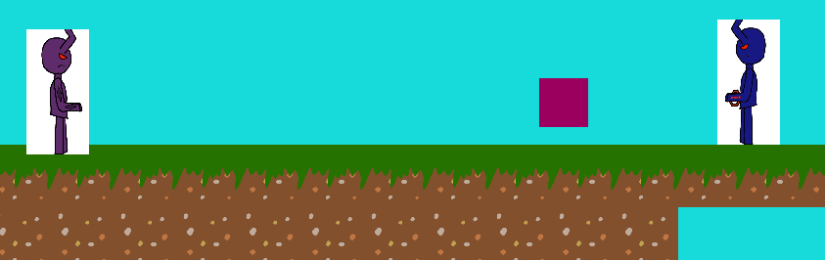

|  |  |  |  |  |  |  |
| --- | --- | --- | --- | --- | --- | --- |
| 1 | Bot collides with regular player bullet but they the power-shot power up. | The enemy receives damage. | Works as intended, does 3 damage. | Yes | Let’s the player do substantial damage to bots if they managed to obtain the power up. | Valid |

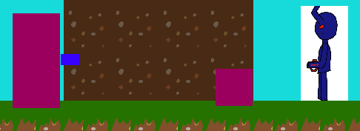

|  |  |  |  |  |  |  |
| --- | --- | --- | --- | --- | --- | --- |
| 1 | Bot HP reaches 0. | The enemy should disappear, and the player receives 150 score. | Works as intended | Yes | let's the player remove their threat. | Valid |



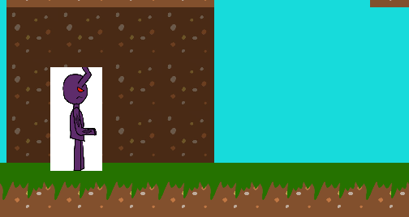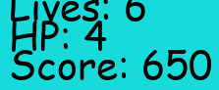

**Testing difficulty scaling**

|  |  |  |  |  |  |  |
| --- | --- | --- | --- | --- | --- | --- |
| 1 | Bot collides with regular player bullet, the player has more than 4 lives or more than 20HP. And player collides with bot bullet with these stats. | The bot should do 3 damage and if the player kills the bot with these stats, then the likelihood of the HP drop occurring should be 1 in 15. Also, the player should only do 1 damage. | Works as intended. | Yes | Adds more difficulty for skilled players. | Boundary |



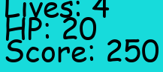

|  |  |  |  |  |  |  |
| --- | --- | --- | --- | --- | --- | --- |
| 1 | If the player has less than 2 lives and they shoot the bot. And player collides with bot bullet with these stats. | The bot should do 2 damage and if the player kills the bot with these stats, then the likelihood of the HP drop occurring should be 1 in 5. Also, the player should do 2 damage. | Works as intended. | Yes | Makes the game easier for players who are doing worse. | Boundary |



Stab Bot Testing.

|  |  |  |  |  |  |  |
| --- | --- | --- | --- | --- | --- | --- |
| Test Noo | Input. | Expected output. | Actual Output. | Correct result? | Justification. | Test type. |

|  |  |  |  |  |  |  |
| --- | --- | --- | --- | --- | --- | --- |
| 1 | Player stands near the bot. | The bot will run at the player and follow them. | Works as intended. | Yes | Ensure the player doesn’t just run at the enemy. | Valid |

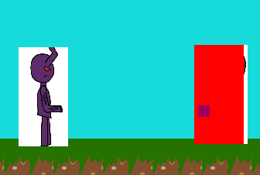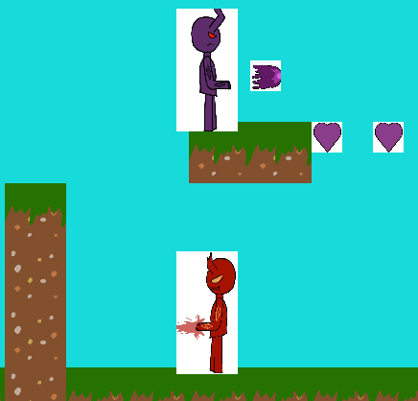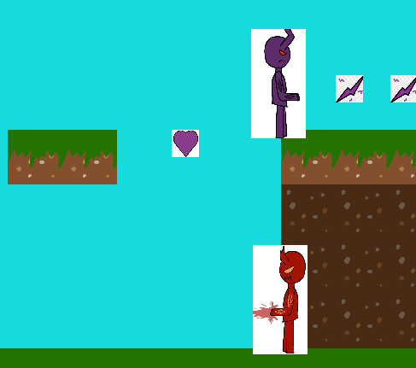

|  |  |  |  |  |  |  |
| --- | --- | --- | --- | --- | --- | --- |
| 1 | Player collides with the enemy. | The player receives damage, and the enemy backs off from the player. | Works as intended. | Yes | Creates a consequence for charging at the bot/ adds difficulty in killing the enemy. | Valid |

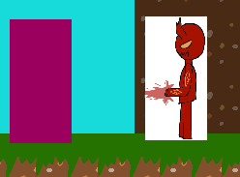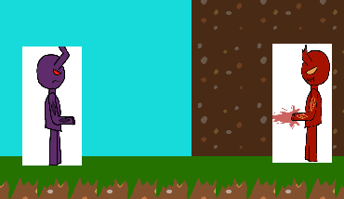

|  |  |  |  |  |  |  |
| --- | --- | --- | --- | --- | --- | --- |
| 1 | Bot collides with regular player bullet. | The enemy receives damage, should be affected by difficulty scaling. | Works as intended, does 1 damage at default/higher difficulties. | Yes | let's the player do damage to the enemy. | Valid |



|  |  |  |  |  |  |  |
| --- | --- | --- | --- | --- | --- | --- |
| 1 | Bot collides with charged player bullet. | The enemy receives damage, shouldn’t be affected by difficulty scaling. | Works as intended does 3 damage. | Yes | Let’s the player do substantial damage do bots if they’re skilled enough with the timing. | Valid |

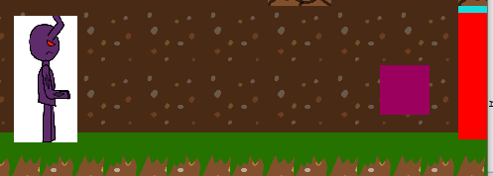

|  |  |  |  |  |  |  |
| --- | --- | --- | --- | --- | --- | --- |
| 1 | Bot collides with regular player bullet but they the power-shot power up. | The enemy receives damage. | Works as intended, does 3 damage. | Yes | Let’s the player do substantial damage to bots if they managed to obtain the power up. | Valid |



|  |  |  |  |  |  |  |
| --- | --- | --- | --- | --- | --- | --- |
| 1 | Bot HP reaches 0. | The enemy should disappear, and the player receives 200 score. | Works as intended | Yes | let's the player remove their threat. | Valid |

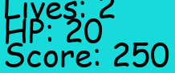

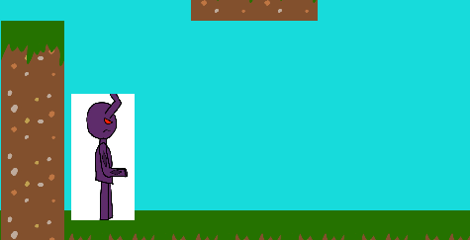

**Testing difficulty scaling**

|  |  |  |  |  |  |  |
| --- | --- | --- | --- | --- | --- | --- |
| 1 | Bot collides with regular player bullet, the player has more than 4 lives or more than 20HP. And player collides with the bot with these stats. | The bot should do 4 damage and if the player kills the bot with these stats, then the likelihood of the HP drop occurring should be 1 in 10. Also, the player should only do 1 damage. | Works as intended. | Yes | Adds more difficulty for skilled players. HP drop chance is still 1 in 10 because it’s a harder enemy to kill. | Boundary |





|  |  |  |  |  |  |  |
| --- | --- | --- | --- | --- | --- | --- |
| 1 | If the player has less than or equal to 2 lives and player collides with the bot with these stats. | The bot should do 2 damage and if the player kills the bot with these stats, then the likelihood of the HP drop occurring should be 1 in 3. | Works as intended. | Yes | Makes the game easier for players who are doing worse. | Boundary |

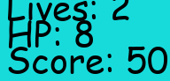

|  |  |  |  |  |  |  |
| --- | --- | --- | --- | --- | --- | --- |
| 1 | If the player has less than or equal to 2 lives and bot collides with the player bullets with these stats. | The player should deal 2 damage to the bot. | Works as intended. | Yes | Makes the game easier for players who are doing worse. | Boundary |

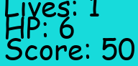

Boss Battle Testing (Given the player an abnormal amount of HP for testing).

|  |  |  |  |  |  |  |  |  |  |  |  |  |
| --- | --- | --- | --- | --- | --- | --- | --- | --- | --- | --- | --- | --- |
| Test Noo | | Input. | | Expected output. | | Actual Output. | Correct result? | | | Justification. | Test type. | |
| 1 | Boss HP reaches 0. | | The enemy should disappear, and the player receives score. | | Works as intended | | | Yes | let's the player beat the game. | | | Valid |



|  |  |  |  |  |  |  |
| --- | --- | --- | --- | --- | --- | --- |
| 1 | Boss HP reaches 18. | Its attacks should have a 3 in 7 chance of occurring. | Works as intended | Yes | Adds difficulty to the boss battle. | Valid |



|  |  |  |  |  |  |  |
| --- | --- | --- | --- | --- | --- | --- |
| 1 | Boss HP reaches half. | Its attacks should have a 3 in 5 chance of occurring. | Works as intended | Yes | Adds difficulty to the boss battle. | Valid |



|  |  |  |  |  |  |  |
| --- | --- | --- | --- | --- | --- | --- |
| 1 | Boss HP is above 19. | Its attacks should have a 3 in 10 chance of occurring. | Works as intended | Yes | Stops attacks from occurring one after another. | Valid |



|  |  |  |  |  |  |  |
| --- | --- | --- | --- | --- | --- | --- |
| 1 | Boss collides with player bullet. | The boss should receive damage based on how well the player is doing and become invincible for a short time. | Works as intended | Yes | let's the player remove their threat. | Valid |

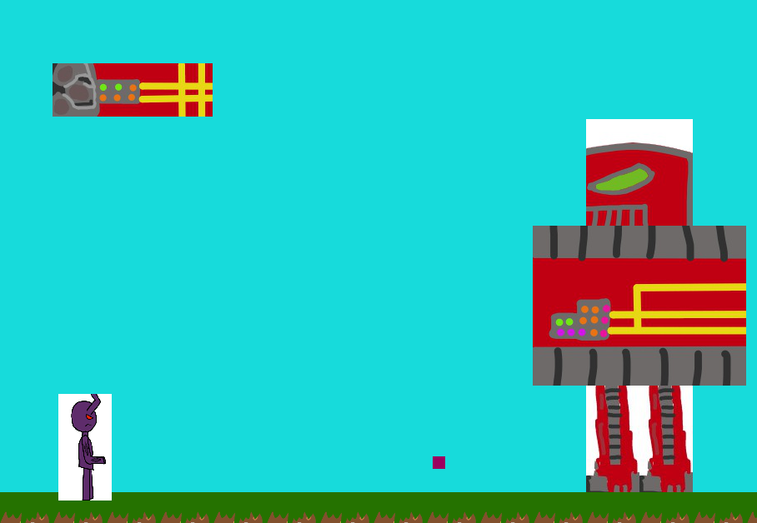

|  |  |  |  |  |  |  |
| --- | --- | --- | --- | --- | --- | --- |
| 1 | Boss collides with player charged bullet. | The boss should receive a constant 3 damage from this attack and become invincible for a short time. | Works as intended | Yes | let's skilled players do more damage to the boss. | Valid |

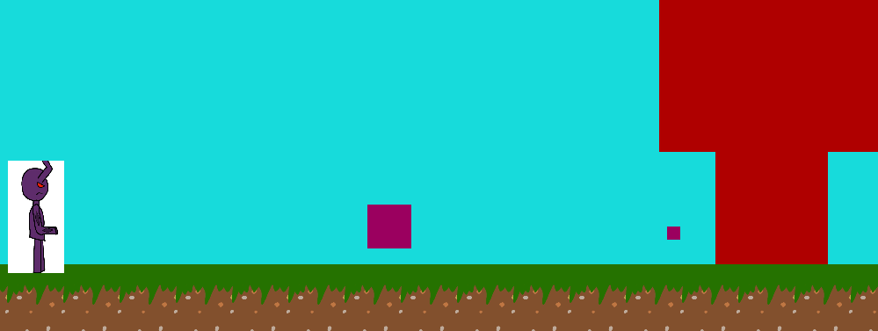

|  |  |  |  |  |  |  |
| --- | --- | --- | --- | --- | --- | --- |
| 1 | Player kills the boss. | The enemy should disappear, and the player receives score depending on how well they did. Should allow the scoreboard to start updating if their new score is higher than their previous. | Works as intended | Yes | let's the game end. | Valid |



 q beat the game but didn’t get a higher score.



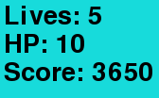 q played and got a higher score.

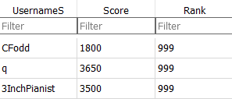

|  |  |  |  |  |  |  |
| --- | --- | --- | --- | --- | --- | --- |
| 1 | RNG land on 1. | Missile attack occurs. | Works as intended | Yes | Boss attacks the player. | Valid |



Missiles fly up from the boss’ arm (this was the last of 5) off screen.

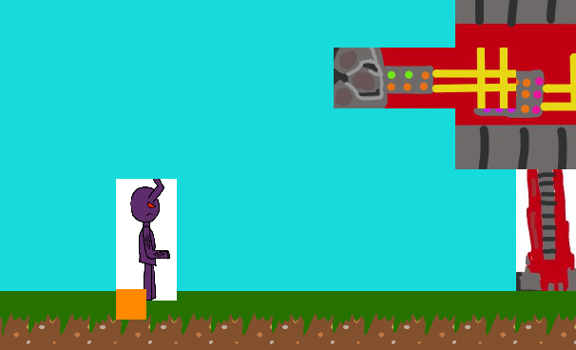

Missiles show where they’re going to fall

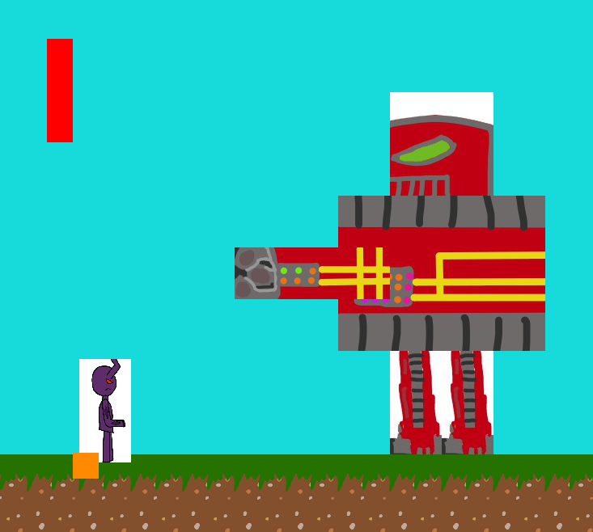

The missiles begin to drop from the sky at the location of the player.

|  |  |  |  |  |  |  |
| --- | --- | --- | --- | --- | --- | --- |
| 1 | RNG land on 2 or the player stands behind the boss. | Stomp attack occurs. | Works as intended | Yes | Boss attacks the player. | Valid |

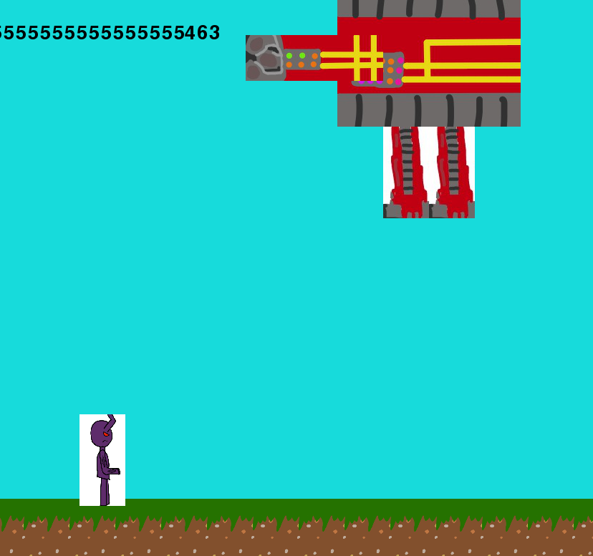

Boss flies up, off-screen.

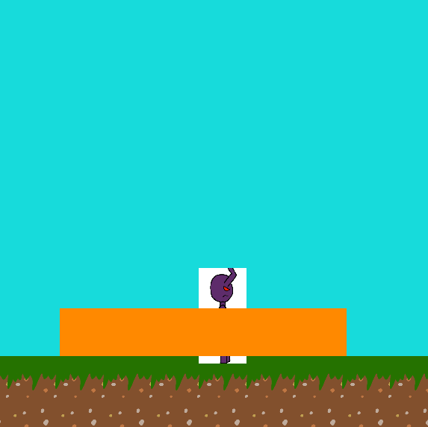

The player is warned where the boss is going to land, as he follows them.

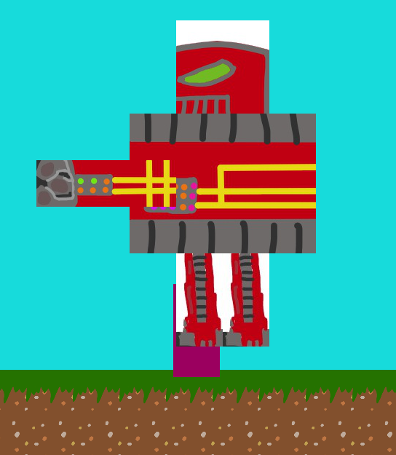

The boss land from the air.

|  |  |  |  |  |  |  |
| --- | --- | --- | --- | --- | --- | --- |
| 1 | RNG land on 3. | Arm slam attack occurs. | Works as intended | Yes | Boss attacks the player. | Valid |

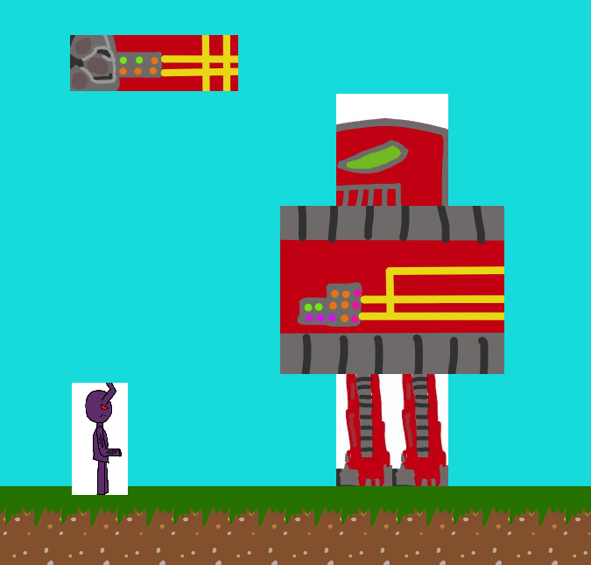

Arm rises above the player and follows them.

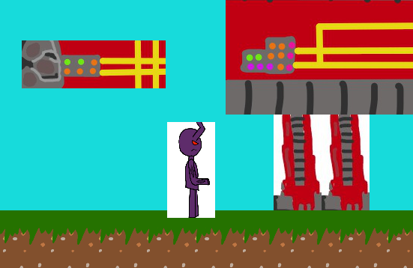

Arm is falling down to the ground.

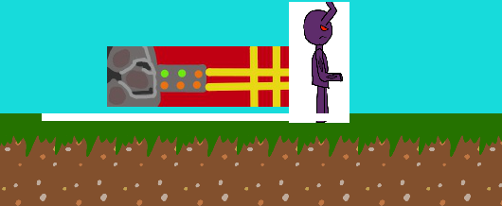

Arm falls to the ground and they can either be hit by the arm or by the dust from the arm.

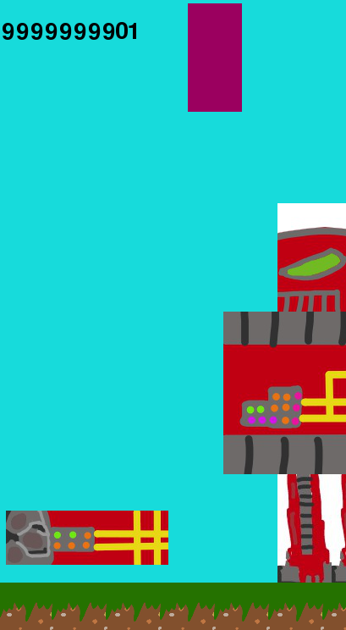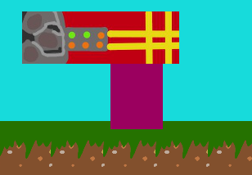

Player is flung into the air after colliding with the dust from the arm or if the arm hits the player then they only receive damage.

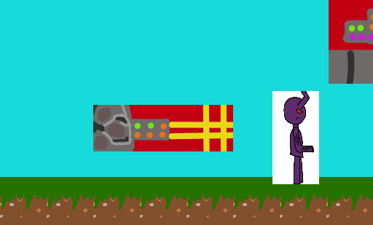

Arm rises up from the floor after it hits the floor.

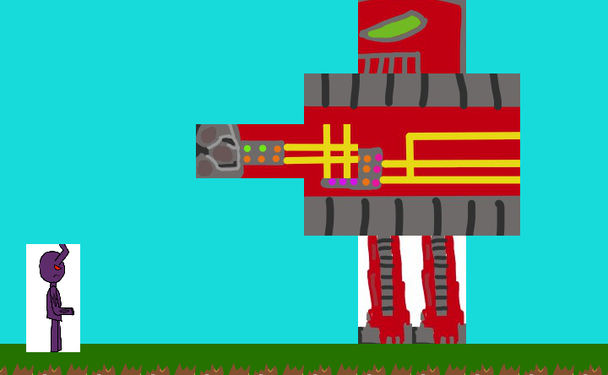

Arm re-attaches to the boss.

**Testing difficulty scaling**

|  |  |  |  |  |  |  |
| --- | --- | --- | --- | --- | --- | --- |
| 1 | Boss collides with regular player bullet, the player has more than 4 lives or more than 20HP. And player collides with the boss’ attacks with these stats. | The boss’ missile attacks should do 5 damage each, his body should now do 3 damage, the arm dust should do 2 damage. The player’s bullet should do one damage. If the player kills the boss with these stats they receive 2000 score. | Works as intended. | Yes | Adds more difficulty for skilled players. | Boundary |

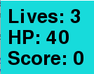or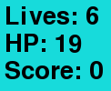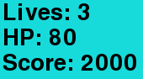 or 

|  |  |  |  |  |  |  |
| --- | --- | --- | --- | --- | --- | --- |
| 1 | If the player has less than 2 lives and they shoot the boss or they have the same stats and the boss attacks. | The boss’s missile attack should only do 2 damage, the boss’ body damage should only do 2 damage and the dust should only do 1. The player should now do 2 damage to the boss. Gives a score of 1500. | Works as intended. | Yes | Removes difficulty for players who are struggling with the game. | Boundary |

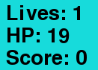 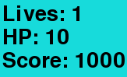

|  |  |  |  |  |  |  |
| --- | --- | --- | --- | --- | --- | --- |
| 1 | If the player has any other range of HP or lives. | The boss’s missile attack should only do 3 damage, the boss’ body damage should only do 2 damage and the dust should only do 1. The player should only do 1 damage to the boss. Gives a score of 1500 after it dies. | Works as intended. | Yes | The regular difficulty of the game. | Boundary |

